**Year 8 Biology Mid Topic Test 2013**

Name:_________________________ Mark: /61

**Multiple choice answer grid**

**1** A B C D

**2** A B C D

**3** A B C D

**4** A B C D

**5** A B C D

**6** A B C D

**7** A B C D

**8** A B C D

**9** A B C D

**10** A B C D

**11** A B C D

**12** A B C D

**13** A B C D

**14** A B C D

[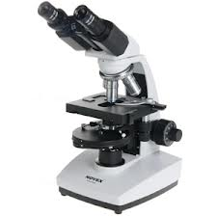](http://www.google.com.au/imgres?hl=en&biw=1920&bih=931&tbm=isch&tbnid=bLMlOWBO-WHRpM:&imgrefurl=http://www.euromex.com/gb/catalog/biological-microscopes/450/&docid=2BmsxYpdcXSO9M&imgurl=http://www.euromex.com/media/images/B%20serie/86325-web.jpg&w=300&h=300&ei=wZCIUdqmD4rakgWLnoC4AQ&zoom=1&ved=1t:3588,r:48,s:0,i:235&iact=rc&dur=1116&page=2&tbnh=186&tbnw=186&start=41&ndsp=53&tx=68&ty=98)**Multiple Choice – Use the answer grid on the first page**

1. One of the descriptions below does not fit this microscope. Which is it?

a. electron microscope

b. stereo microscope

c. light microscope

d. binocular microscope

2. The simplest units of life that we could call alive are:

a. atoms.

b. cells.

c. molecules.

d. proteins

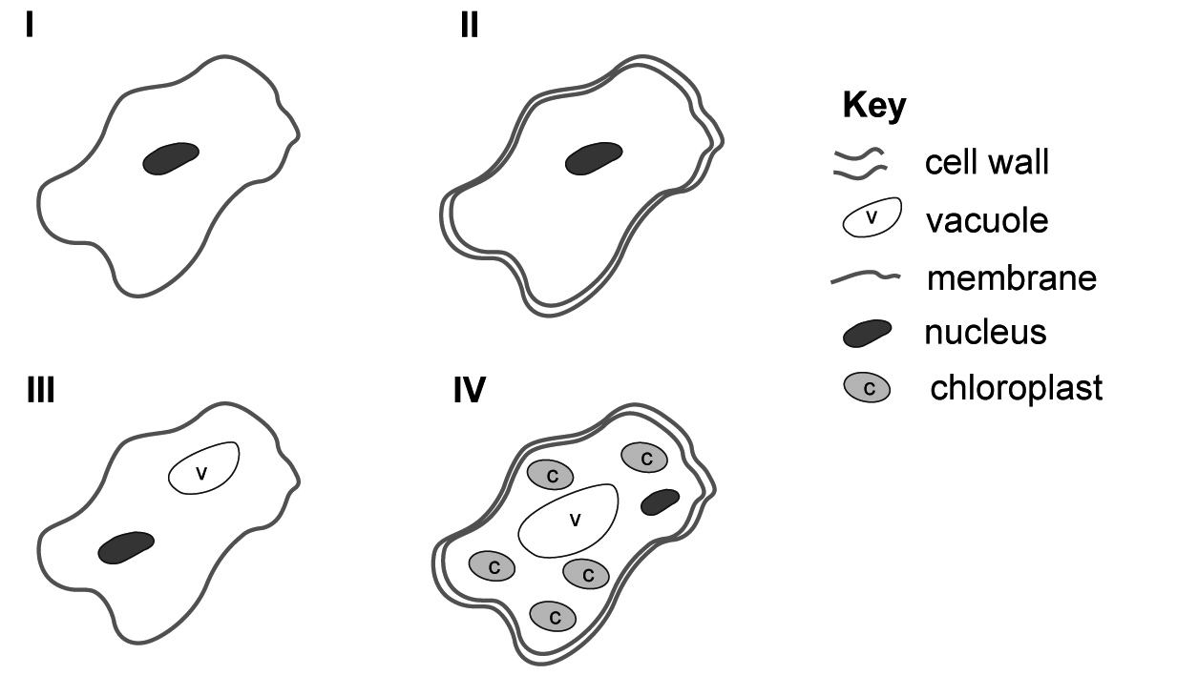3**.** The diagrams below are of several different cells.

Which of these diagrams

is probably a **plant** cell?

a. I

b. II

c. III

d. IV

4. A microscope has an ocular lens of 10x and objective lens of 40x. The total magnification is:

1. 50x.
2. 4x.
3. 200x.
4. 400x.

5. The part of the cell that is responsible for enclosing the cell and controlling what enters or leaves:

1. Cell membrane
2. Nucleus
3. Cytoplasm
4. Mitochondria

6. Which of the following is NOT correct regarding unicellular and multicellular organisms:

|  |  |  |
| --- | --- | --- |
|  | **Unicellular Organisms** | **Multicellular Organisms** |
| a. | Contains organelles | Contains organelles |
| b. | One Cell | Many Cells |
| c. | Has specialised Cells | Has specialised Cells |
| d. | Nucleus controls the cell | Nucleus controls the cell |

7. Which of the following list the levels of organization in the correct order?

1. Organelle, cell, tissue, organ, system, body
2. Organelle, cell, organ, system, tissue, body
3. Organelle, cell, tissue, system, organ, body
4. Organelle, cell, system, organ, tissue, body

8. Which of the following can animals **NOT** do?

a. photosynthesise.

b. respire.

c. grow.

d. respond.

9. The organelle containing the genetic information (DNA) is called the:

1. Cell membrane
2. Nucleus
3. Cytoplasm
4. Mitochondria

10. Plant cells are often green because

a. The golgi bodies contain chloroplasts

b. The chlorophyll contains ribosomes

c. The chloroplasts contain chlorophyll

d. The vacuoles contain a green fluid

11. What process is being shown in the diagram to the right?

[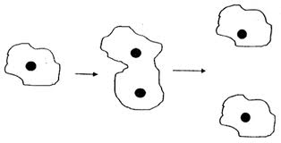](http://www.google.com.au/imgres?start=138&um=1&hl=en&biw=1920&bih=931&tbm=isch&tbnid=ybuqIndSHFAJmM:&imgrefurl=http://www.oldschool.com.sg/index.php/module/PublicAccess/action/Wrapper/sid/9595afb87c8cf767f034c3ae53e74bae/coll_id/1465/recs_ppg/5/desc/Continual+Assessment+1+(#1):+Section+B/pg_id/3&docid=25GH-8tCGJ2OtM&imgurl=http://www.oldschool.com.sg/modpub/17927971804582457c646d4&w=440&h=225&ei=8cmJUem8L8ewkgWP6oHwCA&zoom=1&ved=1t:3588,r:66,s:100,i:202&iact=rc&dur=9871&page=4&tbnh=159&tbnw=313&ndsp=49&tx=127&ty=79)

a. Mitosis

b. Mitochondria

c. Cytoplasmia

d. Meiosis

12. Which of the following is an organ?

a. The villi on the cells lining the small intestine

b. The lining of the small intestine

c. The small intestine

d. The digestive system

13. What is the epithelium?

a. Skin

b. Cell membrane

c. Connective tissue

d. Strands found at the end of each nerve cell

14. Specialised tissue that can contract and become shorter

a. Connective tissue

b. Muscle tissue

c. Tendons

d. Plasma membrane

**Short answer Section**

**15.** Sarah, Emily and Akbar wanted to see how effective washing with soap was at removing unicellular organisms from their hands.

Sarah wiped her unwashed hand on an agar plate. She then washed her hands with soap and wiped her hands on another agar plate. Akbar and Emily did the same.

They incubated the plates for one week then counted the number of colonies that were growing on them.

They got the following results:

|  |  |  |  |  |
| --- | --- | --- | --- | --- |
|  | Number of colonies growing on agar plate | | | |
|  | Sarah | Akbar | Emily | Average |
| Unwashed | 9 | 10 | 8 |  |
| Washed with soap | 2 | 1 | 3 |  |

1. Work out the average number of colonies for washed and unwashed hands and put it on the table. (2)
2. What was the independent variable? (1)
3. What was the dependent variable? (1)
4. What hypothesis were they testing? (2)
5. List 3 variables they should have controlled. (3)
6. What could they do to make the results more reliable? (1)
7. Graph the average results on the grid below: (5)

|  |  |  |  |  |  |  |  |  |  |  |  |  |  |  |  |
| --- | --- | --- | --- | --- | --- | --- | --- | --- | --- | --- | --- | --- | --- | --- | --- |
|  |  |  |  |  |  |  |  |  |  |  |  |  |  |  |  |
|  |  |  |  |  |  |  |  |  |  |  |  |  |  |  |  |
|  |  |  |  |  |  |  |  |  |  |  |  |  |  |  |  |
|  |  |  |  |  |  |  |  |  |  |  |  |  |  |  |  |
|  |  |  |  |  |  |  |  |  |  |  |  |  |  |  |  |
|  |  |  |  |  |  |  |  |  |  |  |  |  |  |  |  |
|  |  |  |  |  |  |  |  |  |  |  |  |  |  |  |  |
|  |  |  |  |  |  |  |  |  |  |  |  |  |  |  |  |
|  |  |  |  |  |  |  |  |  |  |  |  |  |  |  |  |
|  |  |  |  |  |  |  |  |  |  |  |  |  |  |  |  |
|  |  |  |  |  |  |  |  |  |  |  |  |  |  |  |  |
|  |  |  |  |  |  |  |  |  |  |  |  |  |  |  |  |
|  |  |  |  |  |  |  |  |  |  |  |  |  |  |  |  |
|  |  |  |  |  |  |  |  |  |  |  |  |  |  |  |  |
|  |  |  |  |  |  |  |  |  |  |  |  |  |  |  |  |

**16.** Nick drew two diagrams of an amoeba using two different magnifications. Work out the total magnifications he used. (2)

The settings he used were:

X10 occular and x 4 objective _____________________

X 10 ocular and x 10 objective ____________________

Nick can’t remember which diagram he drew using which magnification. Fill in the blanks below to show which was used for each diagram. (2)

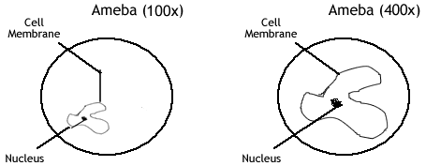

Diagram drawn using x _________ Diagram drawn using x ______________

**17.** Under the microscope Chloe observed a cell which had a cell wall, a nucleus and a large vaculole. It was not green and did not have any chloroplasts. What sort of cell was Chloe looking at? (1)

How could you tell? (1)

**18.** Explain how the structure of each of these cells is suited to its function (6)

[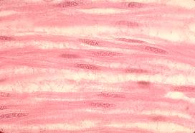](http://www.google.com.au/url?sa=i&rct=j&q=&esrc=s&frm=1&source=images&cd=&cad=rja&docid=w97rdhRpBH85vM&tbnid=RCaiput_xC7I0M:&ved=0CAUQjRw&url=http://www.msu.edu/~lupalisa/webplans/biologyunits/Cells/unitpagecell.htm&ei=06qIUcT7JoPGkAXw84CwCQ&psig=AFQjCNFl0PMqn4-WorfdmPH7AiPjGmjOgw&ust=1367997509571125)Muscle Cells:

[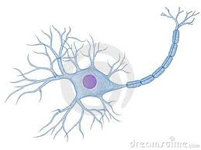](http://www.google.com.au/imgres?start=115&hl=en&biw=1920&bih=931&tbm=isch&tbnid=-kuh-wYIXaoBEM:&imgrefurl=http://www.dreamstime.com/stock-images-nerve-cell-image8854594&docid=nTYX5rF3sziJnM&imgurl=http://www.dreamstime.com/nerve-cell-thumb8854594.jpg&w=400&h=300&ei=GKuIUbifJYG1lQWUuIDgDA&zoom=1&ved=1t:3588,r:18,s:100,i:58&iact=rc&dur=330&page=4&tbnh=177&tbnw=236&ndsp=42&tx=157&ty=75)Nerve Cells

[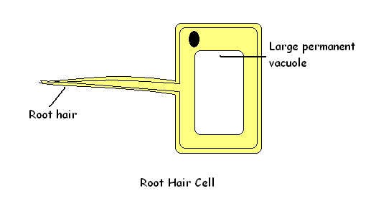](http://misstutor.com/biology/lesson-2-%E2%80%93-specialised-cells/)Root Cell of plant

**19.** Label the diagram below. (5)

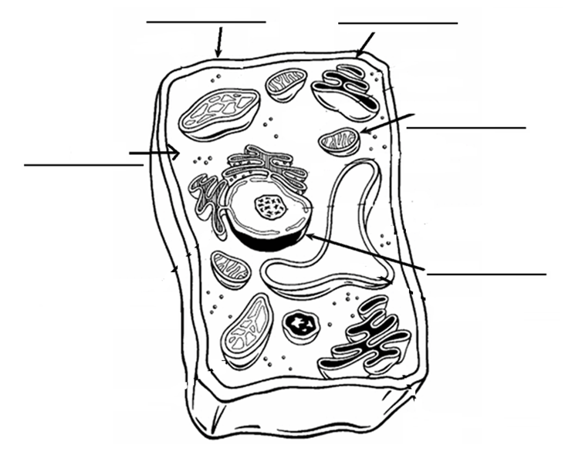

1. What type of cell is this? _____________________________________________ (1)
2. Give a reason for your answer (2)

**20.** Label the following diagram: (8)

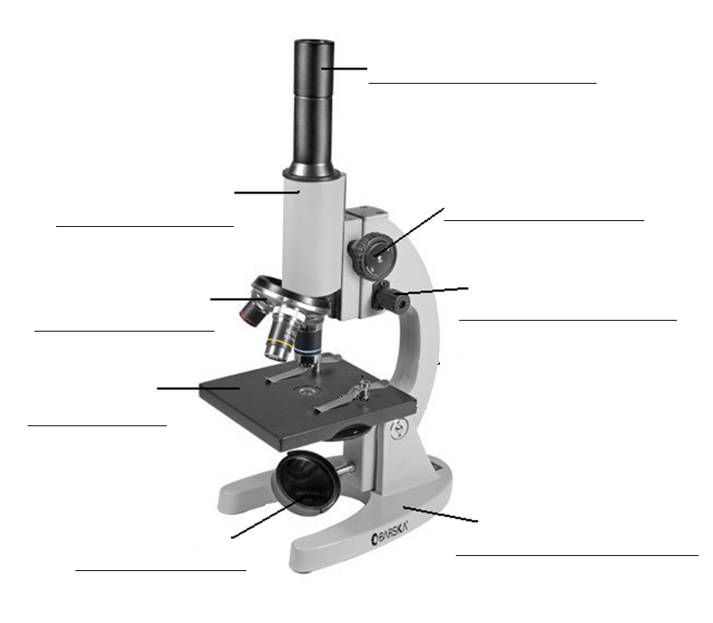

**21.** Convert the following measurements to fill in the blanks. (4)

|  |  |
| --- | --- |
| Millimeters | Micrometers |
| 5 |  |
|  | 100 |
| 23 |  |
|  | 350 |

***End of Test – Please check your answers.***

**Year 8 Biology Mid Topic Test 2013**

**SOLUTIONS**

Mark: /61

**Multiple choice answer grid**

**1** A B C D

**2** A B C D

**3** A B C D

**4** A B C D

**5** A B C D

**6** A B C D

**7** A B C D

**8** A B C D

**9** A B C D

**10** A B C D

**11** A B C D

**12** A B C D

**13** A B C D

**14** A B C D

**Short answer Section**

**15.** Sarah, Emily and Akbar wanted to see how effective washing with soap was at removing unicellular organisms from their hands.

Sarah wiped her unwashed hand on an agar plate. She then washed her hands with soap and wiped her hands on another agar plate. Akbar and Emily did the same.

They incubated the plates for one week then counted the number of colonies that were growing on them.

They got the following results:

|  |  |  |  |  |
| --- | --- | --- | --- | --- |
|  | Number of colonies growing on agar plate | | | |
|  | Sarah | Akbar | Emily | Average |
| Unwashed | 9 | 10 | 8 | 9 |
| Washed with soap | 2 | 1 | 3 | 2 |

1. Work out the average number of colonies for washed and unwashed hands and put it on the table. (2)
2. What was the independent variable? (1) Washing of hands
3. What was the dependent variable? (1) Number of colonies
4. What hypothesis were they testing? (2) 1 correctly worded

1 Uses variables

1. List 3 variables they should have controlled. (3) any 3 suitable
2. What could they do to make the results more reliable? (1) replication or

Increase sample size

1. Graph the average results on the grid below: (5)

Lose one mark for each of the following missing:

* Title
* Units on each axis
* Labels on each axis
* Pencil
* Neat
* Ruler
* Drawn in axis
* Ind variable on horizontal

**16.** Nick drew two diagrams of an amoeba using two different magnifications. Work out the total magnifications he used. (2)

The settings he used were:

X10 occular and x 4 objective x 40 (lose ½ mark if no x)

X 10 ocular and x 10 objective x 100 (lost ½ mark if no x)

Nick can’t remember which diagram he drew using which magnification. Fill in the blanks below to show which was used for each diagram. (2)



Diagram drawn using x 40 Diagram drawn using x 100

**17.** Under the microscope Chloe observed a cell which had a cell wall, a nucleus and a large vaculole. It was not green and did not have any chloroplasts. What sort of cell was Chloe looking at? (1)

FUngi

How could you tell? (1)

Cell wall no chlorophyll

**18.** Explain how the structure of each of these cells is suited to its function (6)

Muscle Cells: long so can contract

Nerve CellsLong to transmit signal over long distance or dendrites and axons to reach next nerve cell

Root Cell of plant root hair to increase surface area to increase absorption

**19.** Label the diagram below. (5)

Cell Wall Cell membrane

Mitochondria

Cytoplasm

Nucleus

1. What type of cell is this? Plant (1)
2. Give a reason for your answer (2)

Cell wall, chloroplasts or rigid shape

**20.** Label the following diagram: (8)

Eyepiece / Ocular lens

Barrel Coarse focus

Knob

Objective lenses Fine focus knob

Stage

Mirror base

**21.** Convert the following measurements to fill in the blanks. (4)

|  |  |
| --- | --- |
| Millimeters | Micrometers |
| 5 | 5000 |
| 0.01 | 100 |
| 23 | 23000 |
| 0.35 | 350 |